***Hotel Reservation System***

A graduation project report submission

In partial fulfilment of the requirements for the award of the degree

Bachelor of Computer Science

Submitted by:

|  |  |
| --- | --- |
| *Omar Mohamed* | *89471* |
| *Mahmoud Hamza* | *77876* |
| *Hamdy Mohamed* | *89455* |
| *Ayham Ahmed* | *77660* |

Under the supervision of Professors: *Dr. Esmat Mohamed*

Supervisor(s):

*TA. Aya Mahmoud*

*TA. Mai Assem*

Department of Computer Science - CS

Misr University for Science and Technology - MUST

College of Computers and Artificial Intelligence Technologies - CAIT

June 2023

**ACKNOWLEDGEMENT**

We would like to express our sincere gratitude and appreciation to Dr. Esmat for his invaluable guidance and support throughout the course of this research project. Dr. Esmat’s expertise and insights were instrumental in shaping the direction of this project and ensuring its success. Dr. Esmat's unwavering support and encouragement provided us with the motivation and inspiration to overcome the challenges that arose during this project. His willingness to provide feedback and guidance at every stage of the project was instrumental in helping us to refine our ideas and produce a high-quality research paper. We would also like to thank Dr. Esmat for his continued support and mentorship, which has been invaluable to us throughout our academic career. His dedication to teaching and research has been an inspiration to us, and we feel privileged to have had the opportunity to work with him. Once again, we would like to express our deep gratitude and appreciation to Dr. Esmat for his guidance and support throughout this project. His contributions have been valuable, and we are grateful for the opportunity to have worked with him.

DECLARATION

I hereby certify that this work, which I now submit for assessment on the programme of study leading to the award of Bachelor of Information Technology in Computer Science is entirely my own work, that I have exercised reasonable care to ensure that the work is original, and does not to the best of my knowledge breach any law of copyright, and has not been taken from the work of others and to the extent that such work has been cited and acknowledged within the references section of this report.

**Signed:** _____________________________

**Registration No.:** ___________

**Date:** 4, July 2023.

ABSTRACT

This project aims to develop a comprehensive hotel booking website that provides users with a seamless and user-friendly experience. The website will allow users to search for hotels, compare prices, and make reservations. The project will involve extensive market research to identify the major players in the hotel booking industry and to understand user needs and preferences. The website will be designed with a focus on usability and user experience, with intuitive navigation, responsive design, and fast loading times. The website will also integrate with third-party systems, such as payment gateways and hotel management systems, to streamline the booking process. Content creation will be a critical component of the project, with a focus on creating compelling and informative hotel descriptions, reviews, and local attraction guides. Finally, the website will be marketed using a range of strategies, including search engine optimization, social media marketing, and email marketing. Overall, this project aims to create a high-quality hotel booking website that meets the needs of users and provides a valuable service to the hotel industry.

Table of Contents

1 INTRODUCTION 5

1.1 overview 5

1.2 problem definition 8

1.3 Objectives 8

1.4 Expected Outcome 9

1.5 Functional & Non-functional Requirments 10

1.5.1 Functional Requirements: 10

1.5.2 Non-Functional: 11

1.6 System Architecture 12

1.7 conclusion 13

2 Related work 14

2.1 Booking: 14

2.1.1 Overview: 14

2.1.2 Features 14

2.2 Trivago: 16

16

2.2.1 Overview: 16

2.2.2 Features: 16

2.3 Tripadvisor 18

2.3.1 Overview: 18

2.3.2 Features: 18

2.4 Comparative Study: 20

3 System analysis 21

3.1 UML Diagrams 21

3.1.1 Context diagram 21

3.1.2 entity relationship diagram (ERD) 21

3.1.3 Class diagram 22

3.1.4 Dataflow diagram 23

3.1.5 Sequence diagram 24

3.1.6 Use case diagram 25

3.1.7 State chart diagram 26

3.1.8 Process model 27

4 PROPOSED SYSTEM 28

4.1 Methodology 28

4.2 Proposed S/W and H/w 30

4.3 Time plan 30

5 RESULTS AND DISCUSSION 31

5.1 Project Outcomes 31

5.2 Cost 33

5.3 Environmental Impact 33

5.4 Manufacturability 33

5.5 Ethics 34

5.6 Social and Political Impact 34

5.7 Health and Safety 34

5.8 Sustainability 34

6 References 35

**LIST OF FIGURES**

**Figure 1.7 System Architecture** 12

**Figure 2. 1: Booking** 14

**Figure 2. 2: Trivago** 16

**Figure 2. 3: TripAdvisor** 18

**Figure 3. 1: Context diagram** 21

**Figure 3. 2: entity relationship diagram (ERD)** 21

**Figure 3. 3: Class diagram** 22

**Figure 3. 4: DFD Level 0** 23

**Figure 3. 5: Sequence Diagram** 24

**Figure 3. 6: Use Case Diagram** 25

**Figure 3. 7: State Chart Diagram** 26

**Figure 3. 8: Process Diagram** 27

**Figure 4.3: Time Plan** 30

**LIST OF TABLES**

**Table 2. 1: Comparative Study** 20

Chapter One

# INTRODUCTION

## overview

The advancement of technology has revolutionized various industries, including the hospitality sector. The convenience and ease of online booking systems have become a necessity for hotels to effectively manage their operations and attract customers. In line with this, our graduation project aims to develop a comprehensive Hotel Booking System that caters to the needs of both hotel administrators and users.

The Hotel Booking System is designed to streamline the hotel reservation process and provide a user-friendly platform for customers to browse and book hotel offers, while enabling administrators to manage hotel listings and handle user reservations efficiently. This system will leverage the power of technology to enhance the overall experience for both administrators and users.

The hotel industry has undergone significant changes in recent years with the rise of online travel agencies (OTAs) and hotel booking websites. These platforms have transformed the way people book their accommodations, providing a more convenient and cost-effective alternative to traditional methods of booking hotels such as travel agents or direct bookings with hotels. The growth of hotel booking websites can be attributed to several factors, including the widespread adoption of technology, the increasing availability of high-speed internet, and the growing demand for travel and tourism. According to a report by the World Travel and Tourism Council, the global travel and tourism industry accounted for 10.4% of global GDP in 2019, and supported 319 million jobs worldwide. The hotel industry is a significant contributor to this sector, and the growth of hotel booking websites has played a crucial role in facilitating the growth of this industry. These platforms have made it easier for travelers to find and book accommodations, while also providing hotels with a new channel for customer acquisition and distribution. Hotel booking websites have become increasingly popular among travelers due to their ease of use, wide selection of hotels, and competitive pricing. These platforms allow users to compare prices, read reviews, and book their accommodations all in one place. In addition, hotel booking websites often offer special deals and promotions that are not available through other booking channels. This has made it easier for travelers to find the best deals and save money on their accommodations, while also allowing hotels to reach new customers and fill empty rooms.

The rapid growth of hotel booking websites has also had a significant impact on the hotel industry itself. OTAs and booking websites have disrupted traditional distribution channels and have given rise to new business models that rely heavily on digital marketing and online customer acquisition. As a result, hotels and other accommodation providers have had to adapt to these changes and find new ways to reach travelers and compete in a crowded marketplace. One of the main challenges facing the hotel booking industry is the tendency for some platforms to prioritize certain hotels or listings over others, often based on factors such as commission rates or advertising budgets. This has led to concerns about fairness and transparency in the industry, as well as questions about the accuracy and reliability of the information provided on these platforms. There is also a growing concern about the impact of these platforms on small and independent hotels, which may struggle to compete with larger chains and brands that have more resources to invest in marketing and advertising. Despite these challenges, hotel booking websites have continued to grow in popularity, with more travelers than ever before booking their accommodations online. This trend has been accelerated by the COVID-19 pandemic, which has forced many travelers to rely on online booking platforms due to travel restrictions and lockdowns. As a result, hotel booking websites have had to adapt to these new conditions and find new ways to serve their customers. The pandemic has highlighted the importance of digital innovation and agility in the travel industry, and has underscored the need for research that can help stakeholders navigate these challenging times. Given the significant impact of hotel booking websites on the travel industry and the wider economy, there is a growing need for research that explores the various aspects of these platforms. By examining the technology, business models, user experience, and other factors associated with hotel booking websites, researchers can gain a deeper understanding of this dynamic and rapidly evolving industry. This research can inform policy decisions, guide industry stakeholders in their decision-making processes, and ultimately contribute to a more efficient, transparent, and consumer-friendly travel market. In this research paper, we will provide an overview of the hotel booking industry, including the history and evolution of hotel booking websites, the technology behind these platforms, and the various business models used by hotel booking companies. We will also examine the user experience of different hotel booking websites, including the features and functionality that are most important to travelers. This will include an analysis of the user interface, the search and booking process, and the customer support offered by these platforms. In addition, we will examine the impact of hotel booking websites on the hotel industry and wider economy, including the challenges and opportunities facing hotels and other accommodation providers. We will explore the impact of hotel booking websites on small and independent hotels, as well as larger chains and brands, and assess the effectiveness of different strategies for competing in a crowded marketplace. Furthermore, we will analyze the data privacy and security issues associated with hotel booking websites. With the increasing amount of personal data being shared online, it is important to examine the privacy and security measures put in place by these platforms to safeguard user information. We will also examine the role of regulations and standards in ensuring data protection and cybersecurity in the hotel booking industry.

## problem definition

In the traditional hotel booking process, both hotel administrators and users face various challenges. Administrators often struggle with manual record-keeping, maintaining updated hotel information, and managing reservations efficiently. On the other hand, users encounter difficulties in finding suitable accommodations, making reservations, and accessing their booking history easily. These challenges can lead to inefficiencies, miscommunications, and inconvenience for both parties involved.

## Objectives

* To create an easy-to-use interface for hotel administrators to add and update hotel offers, manage reservations, and oversee the booking process effectively.
* To develop a user-friendly interface for customers to browse through hotel offers, make reservations, view their booking history, and access their profiles.
* To implement a robust and secure database system that stores hotel information, user details, and reservation data securely.
* To integrate a reliable payment gateway to facilitate secure and convenient transactions for users.
* To ensure seamless communication and notification mechanisms between hotel administrators and users regarding reservation confirmations, updates, and cancellations.
* To optimize the system's performance, scalability, and responsiveness to handle multiple users and simultaneous reservations efficiently.
* To conduct thorough testing and debugging to ensure the system's reliability, security, and user-friendliness.
* To document the development process, including system requirements, design, implementation details, and user instructions for future reference.

## Expected Outcome

Hotel Booking System that simplifies the booking process, enhances communication and efficiency, and provides an improved experience for both hotel administrators and users, ultimately leading to increased customer satisfaction and improved operational effectiveness.

## Functional & Non-functional Requirments

### Functional Requirements:

1. User registration and login: The website should allow users to create an account and sign in securely. This will enable users to save their booking history, preferences, and payment information for future bookings.

2. Hotel search and filtering: The website should allow users to search for hotels based on location, price, availability, and other criteria. The search results should be filterable by amenities, rating, and other factors.

3. Hotel information and reviews: The website should provide users with detailed information about each hotel, including photos, descriptions, amenities, and user reviews. This will enable users to make informed decisions based on their preferences and needs.

4. Booking and payment: The website should allow users to book hotels and make payments securely. This should include options for different payment methods and currencies, as well as the ability to cancel or modify bookings if necessary.

5. Customer support: The website should offer customer support services, including a help center, FAQs, and the ability to contact customer support representatives if needed.

6. Loyalty program: The website could offer a loyalty program that rewards users for booking hotels through the platform. This could include discounts, upgrades, and other perks for frequent users.

7. Mobile optimization: The website should be optimized for mobile devices, with a responsive design that adapts to different screen sizes and devices.

8. Integration with other travel services: The website could integrate with other travel services, such as flights, car rentals, and activities, to offer users a more comprehensive travel booking experience.

9. Data privacy and security: The website should adhere to data privacy and security standards, to protect user information and prevent unauthorized access or use of this information.

10. Sustainable tourism practices: The website could promote sustainable tourism practices, by highlighting eco-friendly hotels, supporting local businesses and communities, and providing users with information about the environmental impact of their travel choices.

### Non-Functional:

1. Usability: The website should be easy to use and navigate, with intuitive interfaces and clear instructions. This will ensure that users can quickly find the information they need and complete bookings without frustration.

2. Performance: The website should be fast and responsive, with quick loading times and minimal lag. This will ensure that users can complete bookings quickly and efficiently, without experiencing delays or downtime.

3. Accessibility: The website should be accessible to users with disabilities, including those who use assistive technologies such as screen readers or keyboard navigation. This will ensure that all users can access the platform and make bookings without barriers.

4. Security: The website should be secure, with robust measures in place to protect user data and prevent unauthorized access. This will ensure that user information is kept safe and confidential, and that users can book hotels with peace of mind.

5. Scalability: The website should be scalable, with the ability to handle large volumes of traffic and bookings without slowing down or crashing. This will ensure that the platform can grow and adapt to changing user needs and demands over time.

6. Reliability: The website should be reliable, with minimal downtime or disruptions. This will ensure that users can consistently access the platform and complete bookings without interruption.

7. Compatibility: The website should be compatible with a wide range of browsers, devices, and operating systems, to ensure that users can access the platform from wherever they are and on whatever device they are using.

8. Internationalization: The website should be designed to support international users, with support for different languages, currencies, and time zones. This will ensure that the platform can cater to users from all over the world, and that users can complete bookings in their preferred language and currency.

9. Compliance: The website should comply with relevant laws and regulations, including data protection laws, anti-discrimination laws, and consumer protection laws. This will ensure that the platform operates ethically and legally, and that users are protected from harm or exploitation.

10. Innovation: The website should be innovative, with the ability to adapt to new technologies, trends, and user needs over time. This will ensure that the platform remains relevant and competitive in a rapidly evolving market.

## A picture containing text, screenshot, diagram, line Description automatically generatedSystem Architecture

**Figure 1.7: System Architecture**

## conclusion

The development of a comprehensive Hotel Booking System has the potential to address the challenges faced by both hotel administrators and users in the traditional hotel booking process. By leveraging technology, the system aims to streamline operations, enhance efficiency, and improve the overall experience for all stakeholders involved.

The Hotel Booking System project strives to revolutionize the hotel booking experience by providing an intuitive and efficient platform that simplifies processes, enhances communication, and ensures a seamless and enjoyable experience for users.

Chapter Two

# Related work

## Booking:

**Figure 2. 1: Booking**

### Overview:

A place to browse and save beautiful photos of inspiring homes. A place to find and hire the right design and construction professionals. A place to connect with others who have been there too. What started as a side project has now grown to a community of millions of homeowners, home design enthusiasts and home improvement professionals around the world.

### Features

* Extensive Accommodation Options: Booking.com boasts a vast inventory of accommodation options, including hotels, apartments, villas, hostels, guesthouses, and more. Users can easily filter and sort through various criteria, such as price, location, facilities, and guest reviews, to find the perfect place to stay.
* User Reviews and Ratings: The platform places a strong emphasis on user reviews and ratings, providing valuable insights from previous guests to help users make informed decisions. Detailed feedback on cleanliness, staff friendliness, location, and other aspects of the property assists travelers in assessing the quality and suitability of the accommodations.
* Flexible Booking Options: Booking.com offers flexible booking options, allowing users to make reservations without upfront payment in many cases. This feature is particularly useful for travelers who prefer to secure their accommodations in advance but pay at a later date or upon arrival.
* Price Comparison and Deals: The platform enables users to compare prices across different accommodations and dates, helping them find the best available deals. Additionally, Booking.com often features special promotions, discounts, and last-minute offers, allowing users to save money on their bookings.
* Multilingual and Global Coverage: Booking.com is available in over 40 languages, catering to a global audience of travelers. Its extensive coverage spans destinations worldwide, ensuring that users can find accommodations in popular tourist spots as well as off-the-beaten-path locations.
* Booking Assistant: The platform offers a virtual assistant called the "Booking Assistant" that uses artificial intelligence to help users with various inquiries and requests. It can provide information about accommodation features, answer common questions, and assist with modifying or canceling bookings.
* Traveler Support: Booking.com provides customer support around the clock to assist travelers with any issues or concerns they may encounter before, during, or after their trips. Support is available via phone, email, or through the platform's messaging system.

## Trivago:

**Figure 2. 2: Trivago**

### Overview:

Trivago.com serves as a metasearch engine for hotels, aggregating information from numerous booking sites and hotel providers. Its primary focus is to simplify the hotel search process by presenting users with a consolidated view of available options, enabling them to make informed decisions based on factors like price, location, amenities, and user reviews.

### Features:

* Hotel Comparison: Trivago's main feature is its ability to compare hotel prices from multiple sources, including online travel agencies, hotel chains, and independent booking websites. By entering their destination and travel dates, users can quickly access a comprehensive list of available hotels and compare prices side by side.
* Extensive Filters and Sorting: Trivago offers a range of filters and sorting options to help users narrow down their search results. These filters may include price range, star rating, guest rating, location proximity, facilities, and more. This allows users to customize their search based on their specific preferences and requirements.
* User Reviews and Ratings: Trivago aggregates user reviews and ratings from various sources, providing valuable insights into the quality and experiences of previous guests. These reviews help users assess the suitability of a hotel based on factors such as cleanliness, service, location, and overall guest satisfaction.
* Price Alerts: Users can set price alerts on Trivago to receive notifications when the price of a particular hotel or destination changes. This feature allows travelers to stay updated on price fluctuations and grab the best deals when prices drop.
* Hotel Information and Descriptions: Trivago provides detailed information and descriptions of each hotel, including photos, amenities, hotel policies, and available room types. This comprehensive information helps users make well-informed decisions and choose accommodations that meet their specific needs.
* Map View and Location Information: Trivago offers a map view feature that displays hotels in relation to popular landmarks, attractions, or specific areas of interest. This helps users visualize the hotel's location and proximity to nearby points of interest, enhancing their decision-making process.
* Mobile Apps: Trivago offers mobile applications for iOS and Android devices, allowing users to search for hotels and compare prices on the go. The apps provide a seamless user experience, making it easy to find and book accommodations from anywhere at any time.
* Customer Support: Trivago provides customer support to assist users with any inquiries or issues they may encounter during the booking process. Support is available through their website, email, or phone, ensuring that users have access to assistance whenever needed.

## Tripadvisor

**Figure 2. 3: Tripadvisor**

### Overview:

Tripadvisor.com serves as a comprehensive resource for travelers, offering a platform where users can access a wide range of travel-related information, reviews, and recommendations. It aims to empower travelers with insights and advice from fellow travelers, helping them plan and book their trips with confidence.

### Features:

* User Reviews and Ratings: One of the key features of Tripadvisor is its extensive collection of user-generated reviews and ratings for accommodations, restaurants, attractions, and more. These reviews provide valuable insights into the experiences of previous visitors, enabling users to make informed decisions based on others' feedback.
* Traveler Forums and Community: Tripadvisor hosts a vibrant community of travelers who actively engage in forums and discussion boards. Users can seek advice, ask questions, and share their own travel experiences, fostering a sense of community and knowledge sharing.
* Accommodation and Restaurant Booking: Tripadvisor offers a booking platform where users can search and book accommodations and restaurants directly through the website. It aggregates prices and availability from various booking partners, providing users with a convenient way to secure their reservations.
* Travel Guides and Itineraries: Tripadvisor provides comprehensive travel guides and itineraries for various destinations, offering curated lists of attractions, things to do, places to eat, and recommended hotels. These guides help users plan their trips and discover hidden gems in their chosen destinations.
* Flights and Travel Packages: In addition to accommodations and restaurants, Tripadvisor allows users to search and compare flights from various airlines. It also offers travel package deals that combine flights, accommodations, and other travel components, providing users with an all-in-one booking solution.
* Mobile Apps and Offline Access: Tripadvisor offers mobile applications for iOS and Android devices, allowing users to access their vast database of information, reviews, and bookings on the go. The apps also provide offline access to saved travel guides and itineraries, ensuring that users can access their trip plans even without an internet connection.
* Tripadvisor Plus: Tripadvisor Plus is a membership program that offers additional benefits to subscribers, such as discounts on select hotel bookings, exclusive deals, and other perks. This program is designed to provide added value and savings for frequent travelers.
* Traveler Safety Information: Tripadvisor provides up-to-date travel safety information, including COVID-19 travel advisories, health and safety guidelines, and destination-specific updates. This feature helps users stay informed about travel restrictions and precautions when planning their trip

## Comparative Study:

|  |  |  |  |
| --- | --- | --- | --- |
| Features | Booking.com | Trivago.com | Tripadvisor.com |
| Accommodation Options | 5/5 | 4/5 | 4/5 |
| User Reviews and Ratings | 5/5 | 4/5 | 5/5 |
| Price Comparison | 4/5 | 5/5 | 4/5 |
| Flexible Booking Options | 4/5 | 3/5 | N/A |
| Multilingual Support | 5/5 | 4/5 | 4/5 |
| Booking Assistant | 4/5 | N/A | N/A |

**Table 2. 1: Comparative Study**

Chapter Three

# System analysis

## UML Diagrams

### A white rectangular object with black text Description automatically generated with low confidenceContext diagram

**Figure 3. 1: Context diagram**

### entity relationship diagram (ERD)

**Figure 3. 2: entity relationship diagram (ERD)**

**Figure 3. 3: Class diagram**

### Dataflow diagram

DFD Level 0:

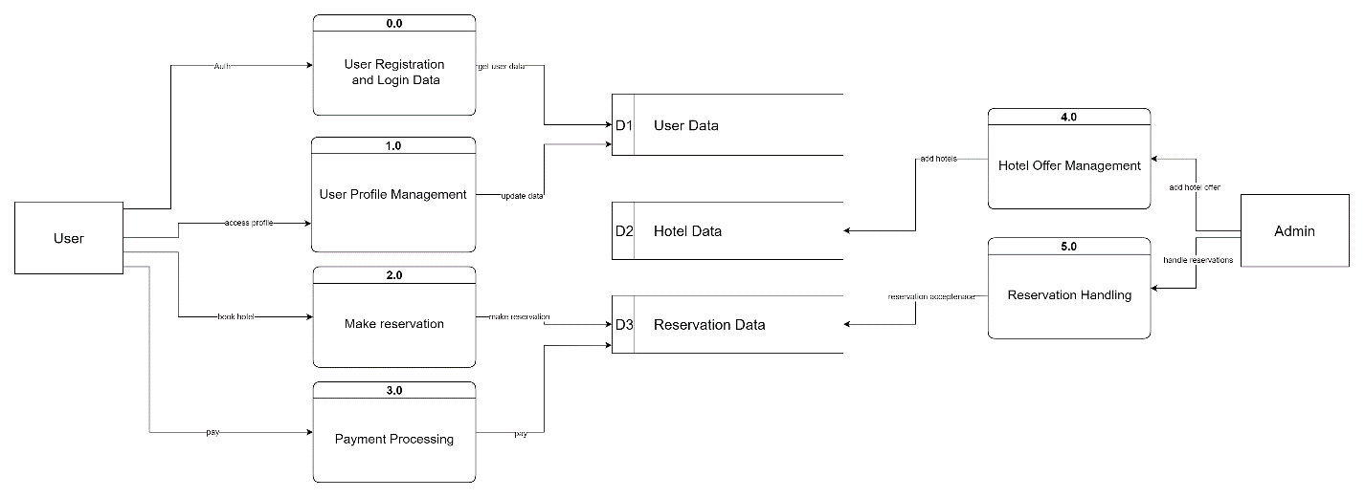

**Figure 3. 4: DFD Level 0**

### Sequence diagram

**Figure 3. 5: Sequence diagram**

### Use case diagram

**Figure 3.6: Use Case diagram**

### State chart diagram

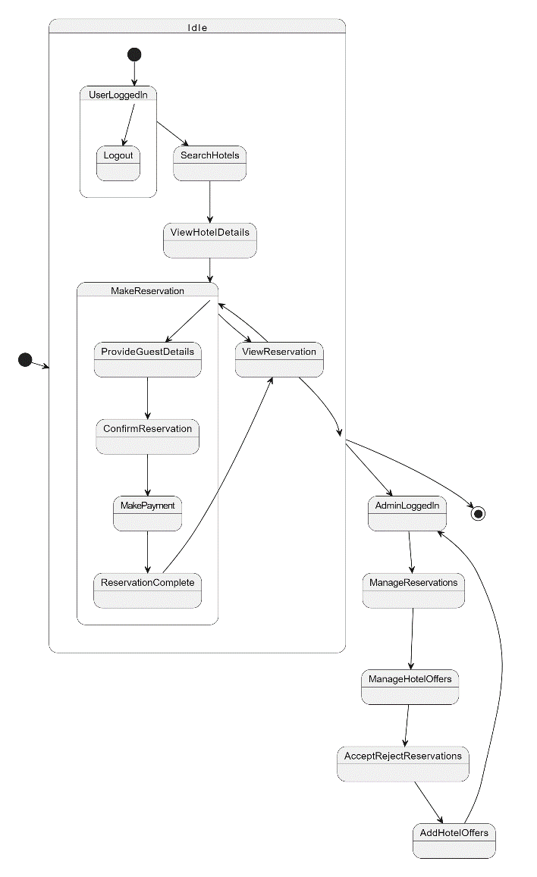

**Figure 3.7: State Chart diagram**

### A picture containing text, diagram Description automatically generatedProcess model

**Figure 3.8: Process diagram**

Chapter Four

# PROPOSED SYSTEM

## Methodology

The Agile methodology is a project management approach that involves breaking the project into phases and emphasizes continuous collaboration and improvement. Teams follow a cycle of planning, executing, and evaluating.

To use the Agile methodology for this project, we would approach it in an iterative and incremental manner, focusing on collaboration, flexibility, and continuous improvement. Here's a high-level breakdown of how the Agile methodology can be applied to this project:

1. Project Planning:
   * Define the project goals, scope, and requirements.
   * Identify the features and functionalities to be implemented in each hotel app.
   * Create a product backlog, prioritizing the features based on customer value and business needs.
2. Sprint Planning:
   * Select a set of features from the product backlog to be implemented in the upcoming sprint.
   * Break down the selected features into smaller, manageable tasks.
   * Estimate the effort required for each task and assign them to the development team.
3. Sprint Execution:
   * Conduct daily stand-up meetings to keep the team synchronized and address any blockers or issues.
   * Implement the selected features according to the requirements and design.
   * Collaborate closely with stakeholders, gathering feedback and making necessary adjustments during development.
4. Continuous Testing and Integration:
   * Perform continuous testing throughout the sprint to ensure the quality and functionality of the hotel apps.
   * Integrate and deploy the developed features frequently to identify and resolve any integration issues early on.
5. Sprint Review and Retrospective:
   * Conduct a sprint review at the end of each sprint to showcase the completed features to stakeholders.
   * Gather feedback from stakeholders and incorporate any necessary changes into the product backlog.
   * Hold a retrospective meeting to reflect on the sprint and identify areas for improvement in the development process.
6. Repeat and Refine:
   * Repeat the sprint cycles, selecting new features from the product backlog for each sprint.
   * Continuously refine and reprioritize the product backlog based on user feedback and changing requirements.
   * Regularly reassess the project goals and make adjustments as needed to ensure the hotel apps meet the evolving needs of users.

## Proposed S/W and H/w

Software:

* Visual Studio
* git, GitHub
* HTML
* CSS
* JavaScript
* Node.js
* React
* Mongo db

Hardware:

* PC

## Time plan

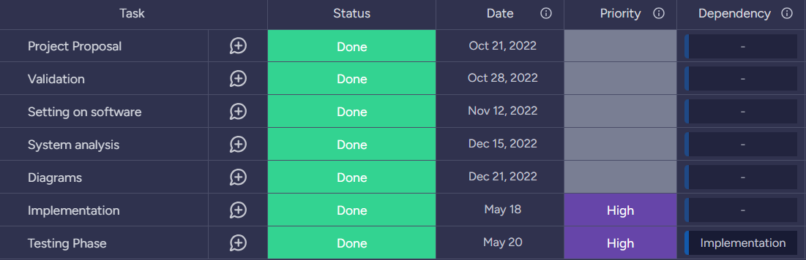

**Figure 4.3: Time Plan**

Chapter Five

# RESULTS AND DISCUSSION

## project outcomes

**Figure 4.2: screen2**

**Figure 4.1: screen1**

1. Identification of key features and functionality required for a successful hotel booking website.

2. Insights into user needs, preferences, and pain points when booking hotel rooms online.

3. A comprehensive understanding of the design and development process for a hotel booking website, including methodologies and best practices.

4. Recommendations for optimizing a hotel booking website for search engines and improving its visibility in search results.

5. Development of a user-centric and effective hotel booking website that meets the needs of both users and hotel managers.

6. Improved user experience and increased conversion rates for the hotel booking website.

7. Enhanced functionality and performance of the website, resulting in increased revenue for the hotel.

Overall, the results of your research will depend on the specific objectives and methodology of your study. However, the ultimate goal should be to create a successful and effective hotel booking website that meets the needs of its target audience and provides value for the hotel.

1. User experience: The user experience is a critical factor for the success of a hotel booking website. Discuss the key design elements that contribute to a positive user experience, such as ease of use, clear navigation, and attractive visuals. You could also explore how emerging technologies like chatbots and virtual reality could be used to enhance the user experience of hotel booking websites.

2. Customer satisfaction: Customer satisfaction is essential for building a loyal customer base and generating repeat business. Discuss the factors that contribute to customer satisfaction on hotel booking websites, such as accurate and up-to-date information, responsive customer service, and a seamless booking process. You could also explore how customer feedback can be used to improve the user experience and increase customer satisfaction.

3. Market analysis: The hotel booking market is highly competitive, with many players vying for a share of the market. Discuss the key trends and factors that are driving growth in the hotel booking market, such as the rise of online travel agencies (OTAs) and the growing popularity of alternative accommodations like Airbnb. You could also explore the challenges that hotel booking websites face in terms of competition, pricing, and regulation.

4. Ethical considerations: Hotel booking websites have a responsibility to protect customer data and ensure that their practices are ethical and transparent. Discuss the ethical considerations that hotel booking websites need to take into account, such as data privacy, security, and the use of customer data for targeted advertising. You could also explore how hotel booking websites can build trust with customers and maintain ethical standards in a highly competitive and fast-changing market.

## Cost

The implementation and maintenance costs of the hotel booking system will depend on factors such as software development, hosting infrastructure, database management, and ongoing support. Considerations should be made to ensure cost-effective solutions are implemented, optimizing resource utilization and minimizing expenses.

## Environmental Impact

The hotel booking system primarily operates as a web application, which can have a relatively low environmental impact compared to traditional paper-based booking methods. By reducing the need for physical documents and promoting digital transactions, the system contributes to the conservation of resources and decreases paper waste.

## Manufacturability

As a web application, the hotel booking system does not involve physical manufacturing processes. However, the development process should consider software engineering best practices to ensure efficient coding, modular design, and scalability. This allows for easier maintenance, updates, and future enhancements.

## Ethics

The hotel booking system should adhere to ethical standards and respect user privacy. Proper handling of personal data, secure storage of sensitive information, and transparent communication of data usage and privacy policies are essential. Additionally, ethical considerations may include fairness in user access to hotel offers and equal treatment of users during the reservation process.

## Social and Political Impact

The hotel booking system can have a positive social impact by providing users with convenient access to hotel information, promoting tourism, and supporting the hospitality industry. From a political standpoint, compliance with applicable laws and regulations, such as data protection and consumer rights, should be ensured to maintain trust and user satisfaction.

## Health and Safety

While the hotel booking system itself does not directly impact health and safety, it should provide accurate and up-to-date information about hotel facilities, amenities, and safety protocols. This allows users to make informed decisions regarding their accommodations, ensuring their comfort and well-being during their stay.

## Sustainability

The hotel booking system can contribute to sustainability efforts by promoting eco-friendly practices. This may include partnering with environmentally conscious hotels, highlighting green initiatives, and providing information on sustainable tourism options. Additionally, by encouraging users to book online and reducing paperwork, the system supports a more sustainable approach to hotel reservations.

# References

|  |  |  |
| --- | --- | --- |
| [1] | A Review of Online Hotel Booking Systems: Research Issues and Opportunities" by Rob Law and Deqing Wang:  Link: https://www.researchgate.net/publication/220713706_A_Review_of_Online_Hotel_Booking_Systems_Research_Issues_and_Opportunities  Description: This paper provides an in-depth review of online hotel booking systems, discussing research issues and opportunities in the field. | |
| [2] | | "Factors Influencing Customers' Intention to Use Online Hotel Booking Systems: Evidence from Saudi Arabia" by Bander Alqahtani:  Link: https://www.emerald.com/insight/content/doi/10.1108/JTF-07-2019-0106/full/html  Description: This article explores the factors influencing customers' intention to use online hotel booking systems, with a focus on the Saudi Arabian context. |
| [3] | | "Analysis of Online Hotel Booking Systems: A Customer Perspective" by Wenchao Zhang and Xudong Gao:  Link: https://ieeexplore.ieee.org/abstract/document/8413400  Description: This research paper presents an analysis of online hotel booking systems from a customer perspective, discussing usability, security, and trust factors. |
| [4] | | "An Investigation of Customer Adoption of Mobile Hotel Booking Systems" by Athina Papadopoulou, Michail Batikas, and Despina Polemi:  Link: https://www.mdpi.com/1996-1073/13/15/4016  Description: This article investigates customer adoption of mobile hotel booking systems, examining factors such as perceived usefulness, ease of use, and trust. |

**المستخلص**

يهدف هذا المشروع إلى تطوير موقع شامل لحجز الفنادق يوفر للمستخدمين تجربة سلسة وسهلة الاستخدام. سيسمح الموقع للمستخدمين بالبحث عن الفنادق ومقارنة الأسعار وعمل الحجوزات. سيتضمن المشروع الكثير من البحث السوقي لتحديد اللاعبين الرئيسيين في صناعة حجز الفنادق وفهم احتياجات وتفضيلات المستخدمين. سيتم تصميم الموقع بتركيز على سهولة الاستخدام وتجربة المستخدم مع تصميم استجابة وأوقات تحميل سريعة. سيتم أيضًا دمج الموقع مع أنظمة الجهات الخارجية مثل بوابات الدفع وأنظمة إدارة الفنادق لتبسيط عملية الحجز. ستكون إنشاء المحتوى جزءًا حاسمًا من المشروع مع التركيز على خلق وصف فندق مقنع ومعلوماتي وإرشادات المعالم المحلية. أخيرًا، سيتم تسويق الموقع باستخدام مجموعة من الاستراتيجيات بما في ذلك تحسين محركات البحث وتسويق وسائل التواصل الاجتماعي والتسويق عبر البريد الإلكتروني. عمومًا، يهدف هذا المشروع إلى إنشاء موقع عالي الجودة لحجز الفنادق يلبي احتياجات المستخدمين ويوفر خدمة قيمة لصناعة الفنادق.

***نظام حجز فنادق***

تقديم تقرير مشروع التخرج

في استيفاء جزئي لمتطلبات منح الدرجة

بكالوريوس العلو م

مقدم من:

|  |  |
| --- | --- |
| *89471* | *عمر محمد* |
| *77876* | *محمود حمزة* |
| *89455* | *حمدي محمد* |
| *77660* | *ايهم احمد* |

تحت اشراف الأستاذ دكتور: عصمت محمد

:المشرفين

*م.اية محمود*

*م.مي عصام*

قسم علوم الحاسب

MUST - جامعة مصر للعلوم و التكنولوجيا

CAIT- كلية الحاسبات وتقنيات الذكاء االصطناعي